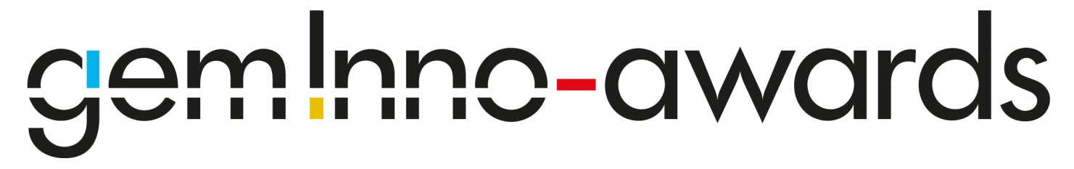

Is Innovation gendered ?

Grenoble Ecole de Management

30 May 2013

Description | Unitprice
Registration to the GEM Inno Awards Workshop  Name : ....................................................................................................... | 50 €

Fees are payable without any deductions

Please transfer to the following account or send a check to Grenoble Ecole de Management, address below.

Reason for Transfer : Your name, Name of your company, and Gem Inno Awards Workshop

Bank : BNP Paribas
BNPPARB ARC ALPIN ENTREP (02475)

FR76 3000 4006 1700 0231 7172 680
BIC (Bank Identification Code) : BNPAFRPPAAE
Account Holder : CCIG-GRENOBLE ECOLE DE MANAGEMENT

Grenoble Ecole de Management
Attn : Séverine Le Loarne 12, Rue Pierre Sémard, 38000 Grenoble, www.grenoble-em.com
Email : Severine.LELOARNE@grenoble-em.com
Tel. (33) 4 76 70 65 07

